**The Most Comprehensive Data Science & Machine Learning Interview Guide You’ll Ever Need**

[**PRANAV DAR**](https://www.analyticsvidhya.com/blog/author/datascience22/)**, JUNE 4, 2018**

[](https://trainings.analyticsvidhya.com/courses/course-v1:AnalyticsVidhya+DS101+2018T2/about?utm_source=AVBlogbwBanner2)

**Introduction**

Are you aspiring to become a data scientist, but struggling to crack the interviews? Well – you’re not alone! Getting a break in the data science field can be difficult. Doubly so, if you’re coming from a non-data science background (which in all likelihood you are).

The stories you hear from other aspiring data scientists can make interviews feel more intimidating and daunting. So you better be prepared before facing the interviews.

What kind of questions can be asked? How can you prepare and what are the resources you should refer to? What is the structure of a typical data science interview? How should your body language be? These are just some of the questions you’ll have in mind.



**Don’t worry – you’re at the right place!**

I have been there as well. Believe me – the only way to crack data science interviews is through sheer practice and through quality of your work. So, make sure you have a **portfolio of projects** you have worked on. [**Check these projects, if you are looking for data science projects**](https://www.analyticsvidhya.com/blog/2018/05/24-ultimate-data-science-projects-to-boost-your-knowledge-and-skills/).

In addition, practice what a typical interview might look like. This will be the focus of this article.

**In this article, we provide you with a comprehensive list of questions, case studies and guesstimates asked in data science and machine learning interviews.** We have also listed additional resources including handy tips and tricks to guide you through your interview process and come out on the other side successfully.

This is the ultimate resource guide you can find. You should bookmark this page for every time you have to prepare for an interview.

Happy learning and all the best!

**Table of Contents**

1. Data Science and Statistics Questions
2. Machine Learning Questions
3. Deep Learning Questions
4. Case Studies
5. Puzzles and Guess Estimates
6. Tool/Language Specific Questions
7. Tips and Tricks for Freshers
8. Other (Really) Helpful Resources for All Aspiring Data Scientists
9. Inspirational Stories

**1. Data Science and Statistics Questions**

This section is meant to test, enhance and improve your data science and statistics concepts. From probability to correlation, linear and regression to logistic regression, your concepts will be set in stone by the time you reach the last question!

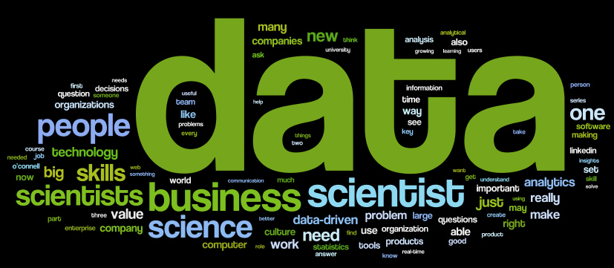

**1.1**[**40 Interview Questions asked at Startups in Machine Learning/Data Science**](https://www.analyticsvidhya.com/blog/2016/09/40-interview-questions-asked-at-startups-in-machine-learning-data-science/)

This is a list of 40 plausible & tricky questions which are likely to come across your way in interviews. If you can answer and understand these questions, rest assured, you will give a tough fight in your job interview. The key to answering these questions is to have a concrete **practical** understanding of ML and related statistical concepts.

**1.2**[**40 Questions on Probability for Data Science**](https://www.analyticsvidhya.com/blog/2017/04/40-questions-on-probability-for-all-aspiring-data-scientists/)

Probability is considered the backbone of quite a few data science concepts and techniques. You will need to have a good grasp on this subject in order to have a chance to land a data science role. These questions will test how well you know probability.

**1.3**[**7 Most Commonly Asked Questions on Correlation**](https://www.analyticsvidhya.com/blog/2015/06/correlation-common-questions/)

Correlation is one of the core concepts in data science. It seems easy from the outside but it has it’s own tricky features. If you are learning statistical concepts, you are bound to face these questions which mostly people try to avoid. For folks who are well versed with statistics, this will be a good refresher.

**1.4**[**41 Questions on Statistics for Data Scientists and Analysts**](https://www.analyticsvidhya.com/blog/2017/05/41-questions-on-statisitics-data-scientists-analysts/)

Your statistical concepts should be rock solid before you go for an interview in this field. To help you improve and test your knowledge on statistics, we have put together this list of questions. The article covers both descriptive and inferential statistics along with explanations for each question.

**1.5**[**30 Questions to Test a Data Scientist on Linear Regression**](https://www.analyticsvidhya.com/blog/2017/07/30-questions-to-test-a-data-scientist-on-linear-regression/)

Linear Regression is still one of the most prominently used statistical techniques in the data science industry and in academia to explain relationships between features. It is a technique you absolutely MUST KNOW inside out if you want to become a data scientist.

**1.6**[**30 Questions to test your Understanding of Logistic Regression**](https://www.analyticsvidhya.com/blog/2017/08/skilltest-logistic-regression/)

Logistic Regression is likely the most commonly used algorithm for solving all classification problems. The questions in this article are especially designed for you to test your knowledge on logistic regression and its nuances.

**2. Machine Learning Questions**

Machine learning has become central to a lot of organizations strategies. If you want to carve a career for yourself in this field, you should be prepared to face the hard questions. This section will definitely test your ML techniques to the limit.



**2.1**[**40 Questions to test a Data Scientist on Machine Learning**](https://www.analyticsvidhya.com/blog/2017/04/40-questions-test-data-scientist-machine-learning-solution-skillpower-machine-learning-datafest-2017/)

If you are a data scientist (or an aspiring one), then you need to be good at Machine Learning – no two ways about it. These questions have been designed to test your conceptual knowledge of machine learning and make you industry ready. Get ready to test yourself!

**2.2**[**30 Questions to test a Data Scientist on Natural Language Processing**](https://www.analyticsvidhya.com/blog/2017/07/30-questions-test-data-scientist-natural-language-processing-solution-skilltest-nlp/)

Natural Language Processing (NLP) is the science of teaching machines how to understand the language we humans speak and write. It is a very upcoming field in machine learning. Organizations are waking up to the power of how ML can be used to gain actionable insights from text. Go through these questions and see how well versed you are with NLP.

**2.3**[**30 Questions to test a Data Scientist on Tree Based Models**](https://www.analyticsvidhya.com/blog/2017/09/30-questions-test-tree-based-models/)

Decision Trees are one of the most respected algorithm in machine learning and data science. They are transparent, easy to understand, robust in nature and widely applicable. You can actually see what the algorithm is doing and what steps does it perform to get to a solution. This trait is particularly important in business context when it comes to explaining a decision to stakeholders, which makes an integral part of the interview process as well.

**2.4**[**25 Questions to test a Data Scientist on Support Vector Machines**](https://www.analyticsvidhya.com/blog/2017/10/svm-skilltest/)

You can think of machine learning algorithms as an armoury full of axes, sword and blades. You have various tools, but you ought to learn to use them at the right time. ‘Support Vector Machines’ is like a sharp knife – it works on smaller datasets, but on them, it can be much more stronger and powerful in building models. Test yourself with these 25 questions to enhance your knowledge of this wonderfully adept technique.

**2.5**[**40 Questions to test a Data Scientist on Dimensionality Reduction Techniques**](https://www.analyticsvidhya.com/blog/2017/03/questions-dimensionality-reduction-data-scientist/)

One of the most common questions in interviews is based on how you will deal with a massive dataset that consists of millions of rows and thousands of columns. Knowing dimensionality reduction techniques and when to use them comes in handy in these cases.

**2.6**[**40 Questions to test a Data Scientist on Clustering Techniques**](https://www.analyticsvidhya.com/blog/2017/02/test-data-scientist-clustering/)

Clustering plays an important role to draw insights from unlabeled data. It classifies the data in similar groups which improves various business decisions by providing a meta understanding. It is used in industries like marketing, finance and many others. It’s another must-know concept you should have a good grasp on.

**3. Deep Learning Questions**

Deep learning is the hottest research field in the industry right now. It has led to amazing innovations, incredible breakthroughs, and we are only just getting started! But jobs in this field are few and far between. If you manage to land an interview, you need to be completely prepared for the hard questions – there is no easy way out when you work in the deep learning domain. This section will tell you how prepared (or not) you are to apply and sit for these interviews.

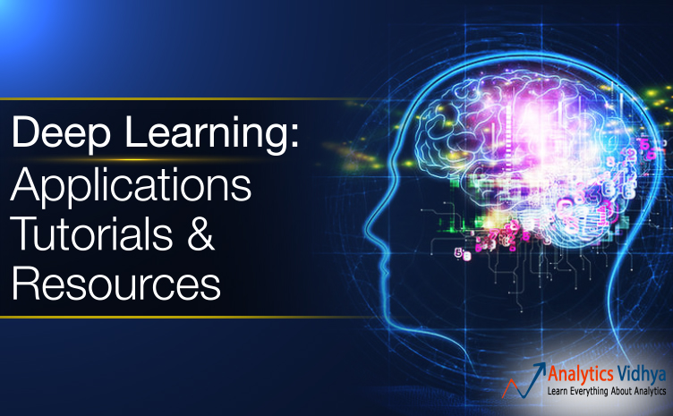

**3.1**[**45 Questions to Test a Data Scientist on the Basics of Deep Learning**](https://www.analyticsvidhya.com/blog/2017/01/must-know-questions-deep-learning/)

This is a relatively easier set of questions that are MUST-KNOW if you wish to work in deep learning. Before you go further down this section, take this quiz first and then see where you stand. If you don’t understand a concept, the article has links to resources where you can learn them. Get going!

**3.2**[**30 Questions to test a Data Scientist on Deep Learning**](https://www.analyticsvidhya.com/blog/2017/08/skilltest-deep-learning/)

This is as good a place to start as any to test your deep learning knowledge. This contains basic as well as advanced questions. When we released this quiz, most people clearly took it without having an inherent knowledge of the subject. Can you do better? Go for it!

**3.3**[**40 Questions to Test a Data Scientist on Deep Learning**](https://www.analyticsvidhya.com/blog/2017/04/40-questions-test-data-scientist-deep-learning/)

This article carries on from the above one. It will test your conceptual knowledge of deep learning.

**3.4**[**25 Questions to test a Data Scientist on Image Processing**](https://www.analyticsvidhya.com/blog/2017/10/image-skilltest/)

When it comes to deep learning, image processing is the leading domain right now. With big players like Google and IBM launching automated platforms to build image classification models, the interest in this field is pretty high. The questions in this article are especially designed for you to test your knowledge on how to handle image data, with an emphasis on image processing.

**3.5**[**12 Frequently Asked Questions on Deep Learning**](https://www.analyticsvidhya.com/blog/2018/05/deep-learning-faq/)

While these are not specifically interview based, you should have a comprehensive answer for each of these 12 questions. These are some of the most basic questions around deep learning and should be on your fingertips.

**4. Case Studies**

Case studies are an integral part of the data science interview process. The hiring manager will be sure to check how you structure your thinking when faced with a case study. Ensure you go through the below case studies in detail. Before you see the solutions, first solve the problem yourself and then check your answers.



**4.1**[**Solve Interview Case Studies 10x Faster using Dynamic Programming**](https://www.analyticsvidhya.com/blog/2016/05/ase-studies-10x-faster-using-dynamic-programming/)

Dynamic Programming isn’t a trick or a mathematical formula which delivers correct answer just by providing the inputs. Rather, it’s a combination of structured thinking & analytical mindset which does the job. The concept is an old one, yet used by just few of us. Learn this unique approach and your interviewer will be bowled over!

**4.2**[**Case Study for Analytics Interviews – Dawn of Taxi Aggregators**](https://www.analyticsvidhya.com/blog/2016/04/case-study-analytics-interviews-dawn-taxi-aggregators/)

Taxi aggregators have become a MASSIVE deal in certain parts of the country.  In this article, we’ll solve a case study of taxi aggregators. Along side this, we will also focus on the essentials required for solving a case study like a pro. Consulting firms like Bain, BCG and McKinsey prefer candidates who think like a pro when given any case study. Let’s make you one.

**4.3**[**An Analytics Interview Case Study**](https://www.analyticsvidhya.com/blog/2014/02/interesting-analytics-case-study/)

This is a classic route optimization problem. You are given data about alternate roads and have to figure out possible routes that minimize the time taken to travel. As you answer each question, you are provided more and more data to dive deeper into the case study. This is exactly how it happens in the interview room so strap in!

**4.4**[**Case Study for Freshers: Call Center Optimization (Level: Medium)**](https://www.analyticsvidhya.com/blog/2016/04/case-study-level-medium-call-center-optimization/)

In this article, we will look at a real life case in the form of a call center optimization problem. This case study will give you a good feel of how to simulate an entire environment in such an operation intensive function. The codes mentioned here are in R but even if you don’t know the tool, you can work out the problem in Excel.

**4.5**[**Case Study: Optimize the Price of Products for an Online Vendor (Level: Hard)**](https://www.analyticsvidhya.com/blog/2016/07/solving-case-study-optimize-products-price-online-vendor-level-hard/)

This case study is a classic because of it’s applications in the real world. The objective of  this case study is to optimize the price level of products for an online vendor. The calculations which you’ll need to perform are ones which often take place in real life. Therefore, it’s not just mathematical, but practical too. For experienced job roles, similar case studies often appears in job interviews. So, give your best attempt!

**5. Puzzles and Guess Estimates**

If you aspire to become a data scientist, your out-of-the-box thinking and ability to quickly calculate and structure your thoughts is critical. One of the first things the interviewer will test you on is exactly this. You will be given a puzzle or a guess estimate questions (sometimes both) to see how quickly and logically you solve a challenging problem. This section will help you be prepared to crack such challenges!



**5.1**[**Tips to Crack a Guess Estimate Problem**](https://www.analyticsvidhya.com/blog/2014/01/tips-crack-guess-estimate-case-study/)

Guess estimate questions are very common in analytics and management consulting interviews. If you wish to crack the data science interview, this article will be very useful in going past the first step. In this article you will walk through some tried and tested techniques to crack guess estimates.

**5.2**[**20 Challenging Job Interview Puzzles which every analyst should solve at least once**](https://www.analyticsvidhya.com/blog/2016/07/20-challenging-job-interview-puzzles-which-every-analyst-solve-atleast/)

In this article, the author has covered some of the trickiest and most challenging puzzles he was given while interviewing for data science roles. These questions have been asked at companies like Goldman Sachs, Amazon, Google, JP Morgan, etc.

**5.3**[**3 Tricky Puzzles which most people get Wrong in Job Interviews**](https://www.analyticsvidhya.com/blog/2016/01/3-tricky-puzzles-people-wrong-job-interviews/)

This article contains 3 of the most challenging puzzles which most people get wrong in interviews. Since these questions are tricky to understand at first, it’s perfectly fine even if you do not figure out the answer in your first attempt. Don’t give up though! Sometimes the most tricky questions can have the simplest of solutions.

**5.4**[**Commonly asked Puzzles in Analytics Interview (Part 1)**](https://www.analyticsvidhya.com/blog/2014/09/commonly-asked-puzzles-analytics-interviews/)

These cover some of the most common puzzle questions asked in interviews. These are some of the easier puzzles so you should not have too hard a time in solving them. In case you were not able to crack two of the puzzles within the given time limits, you might need to solve different variety of puzzles to get a hang of these types of questions.

**5.5**[**Commonly asked Puzzles in Analytics Interview (Part 2)**](https://www.analyticsvidhya.com/blog/2014/10/commonly-asked-interview-puzzles-part-ii/)

Part 2 of this article continues in the same vein as the above one – puzzles from easy to high level of difficulty. The puzzles are divided into 3 stages and you have not been given solutions to the first stage, If you don’t get those answers yourself, you might need to go through puzzle solving from scratch!

**6. Tool/Language Specific Questions**

Every aspiring data scientist must have mastery over at least one tool in order to produce quality analysis. But the more tools you know, the diverse your skillset becomes, hence increasing your chances of landing your preferred role. Questions on tools are a mandatory part of every data science interview and you should have certain things already in your mind before you face the panel. This section takes care of the questions related to Python, R, SQL and SAS.



**6.1**[**40 Questions to Test your Skill on R for Data Science**](https://www.analyticsvidhya.com/blog/2017/05/40-questions-r-for-data-science/)

This article is a comprehensive test of your R skills. From coding questions to conceptual ones, you will need to be quick on your feet to give rapid answers. I would suggest timing yourself with each question so you don’t hesitate when it comes to facing the interview panel.

**6.2**[**4 Tricky R Interview Questions**](https://www.analyticsvidhya.com/blog/2014/05/tricky-interview-questions/)

R is one of the most popular languages in use today, thanks to it’s open source nature and an excellent user community. These 4 questions are some of the trickiest you might have to handle in pressure situations. Better be prepared!

**6.3**[**4 Tricky SAS Questions Commonly Asked in Interviews**](https://www.analyticsvidhya.com/blog/2013/11/4-sas-tricky-analytics-interview/)

What distinguishes SAS from other such languages is its simplicity to code. There are some very tricky SAS questions and handling them can become overwhelming for some candidates. This article covers 4 such questions with detailed examples to help you get started.

**6.4**[**Tricky Base SAS Interview Questions**](https://www.analyticsvidhya.com/blog/2014/04/tricky-base-sas-interview-questions-part-ii/)

This is essentially a continuation of the above article. These questions are tougher and lengthier than those covered in the first part of this article series. These questions are widely asked in companies that have a broad analytics base and deal with big data on a daily basis.

**6.5**[**40 Questions to Test your Skill in Python for Data Science**](https://www.analyticsvidhya.com/blog/2017/05/questions-python-for-data-science/)

Python has well and truly taken the lead in the data science tools debate. This is a must-read list of questions about this awesome programming language. Before you go for any data science interview, ensure you test yourself with these questions so your base is rock solid.

**6.6**[**42 Questions on SQL for all Aspiring Data Scientists**](https://www.analyticsvidhya.com/blog/2017/05/questions-sql-for-all-aspiring-data-scientists/)

Irrespective of which language you use to build your models, SQL is a mandatory addition to your CV. Without it, your chances of landing a data scientist role are little to none. This is a comprehensive list of questions that will ensure your SQL skills are polished and ready to go.

**7. Tips and Tricks for Freshers**

Getting that first break in analytics is critical for students coming out of college. Some get lucky when they’re picked up by organizations and then placed in analytics. But you can’t reply on luck alone! This section is especially for freshers to better prepare you for acing your interview process.

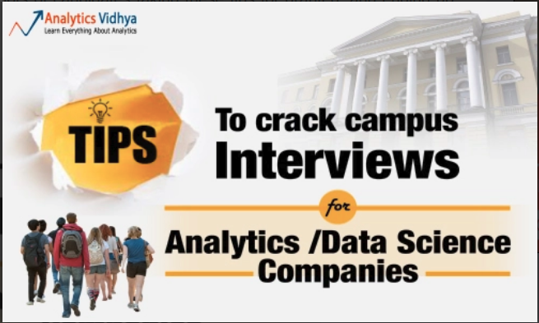

**7.1**[**Tips for Freshers to Crack Campus Interviews for Analytics/Data Science Companies**](https://www.analyticsvidhya.com/blog/2015/11/tips-crack-campus-interviews-non-core-companies/)

The author of this article has analyzed the essential patterns for cracking campus interviews. These patterns can help you in clearing any type of analytics interview. Here he has shared these insights along with some useful interview tips. A lot of candidates often take these tips for granted, and end up getting disappointed when the offer letter fails to materialize.

**7.2**[**How Freshers can Ace Interviews for Business Analytics Roles**](https://www.analyticsvidhya.com/blog/2013/07/prepare-ace-interviews-business-analytics-roles/)

Campus interviews can be very competitive, especially so, if you want to secure a job with the best companies. Further, if you are a fresher, the experience of giving interviews can be unnerving at times. However, you can train yourself to make sure that you present your best when it matters the most. This article provides some tips using which you can blaze through any analytics interview.

**8. Other (Really) Helpful Resources for All Aspiring Data Scientists**

So far we have covered the question and answer part of the interview process. But even having that knowledge might not be enough if you don’t follow the tips and behavioural guidelines covered in this section! Things like body language, the way you structure your thoughts, your awareness of the industry, domain knowledge and how caught up you are with all the latest developments in machine learning – these all matter a great deal.



**8.1**[**Beware – Interviewer for the Analytics Job is Observing you Closely!**](https://www.analyticsvidhya.com/blog/2015/06/analytics-interview-behaviour-to-avoid/)

As an analyst, getting into details and studying them carefully, almost becomes second nature to you. **In an interview, you will likely be interviewed by someone who has been an analyst for a longer duration that you have been.** Hence, you should expect a thorough and close examination of minute details. The tips mentioned here will prove to be very handy.

**8.2**[**Definitive Guide to prepare for an analytics interview**](https://www.analyticsvidhya.com/blog/2014/07/definitive-guide-prepare-analytics-interview/)

This article lays down the general structure of an analytics interview. It covers aspects like the different points the employer judges you on, the different stages of an interview, how a technical interview is conducted, etc. This guide is meant to help you ace the next analytics interview you sit for!

**8.3**[**8 Essential Tips for People Starting a Career in Data Science**](https://www.analyticsvidhya.com/blog/2017/10/tips-people-starting-career-data-science/)

Which tool to learn – R or Python? What techniques to focus on? How much statistics to learn? Do I need to learn coding? These are some of the many questions you need to answer as part of your data science journey. This was the idea behind writing this simple and not very long article. It sets a framework which can help you learn data science through your initial stages.

**8.4**[**10 Things you Should Know about Analytics Related Career**](https://www.analyticsvidhya.com/10-analytics-related-career/)

This is an awesome resource – it’s a guide within a guide! Its a curated list of articles based on career related suggestions and knowledge. These articles will help you get acquainted with the steps that you must take if you are planning to enter the analytics industry.

**8.5**[**Moving into Analytics After a Break in Career? Don’t Expect a Rosy Land!**](https://www.analyticsvidhya.com/blog/2015/05/moving-analytics-break-career-expect-rosy-land/)

Can you relate to the heading? A lot of people take a 1-3 year break for various reasons during their career. How can a person without past experience get a break in analytics? In this article, Kunal draws on his wealth of experience and gives his own perspective on this question.

**8.6**[**The lack of Analytics Work Experience and how to Overcome it**](https://www.analyticsvidhya.com/blog/2014/05/no-analytics-work-experience/)

Like the above article, this one also aims to help folks with no prior experience in this field get a break in analytics. There are very valid points that apply to both freshers as well as people with experience. Kunal has written this from the perspective of both employer and prospective candidate which makes this a must-read!

**8.7**[**Planning a Late Career Shift to Analytics/Big Data? Better be Prepared!**](https://www.analyticsvidhya.com/blog/2014/05/planning-late-career-shift-analytics-big-data-prepared/)

This is one of the most common questions floating around in the last 4 years and this article gives the low down on what to expect. It doesn’t pull any punches and tells the situation like it is – the challenge is going to be tough but it can be overcome with a lot of hard work and dedication. The tips mentioned in here are invaluable.

**8.8**[**How to Train your Mind for Analytical Thinking?**](https://www.analyticsvidhya.com/blog/2014/01/train-mind-analytical-thinking/)

As you make calculations on a daily basis, they become more reflexive and accurate. An average working person in weekday spends 25-30% of his time sleeping, 40-60% of his time working , 10% of time eating and 15-25% idle. In this busy world more than 50% of our idle time is spent on road. You can use this particular time to develop sharper reflexes on numbers. This article illustrates some engaging methods that you can use in this idle time to sharpen your brain’s reflexes.

**8.9**[**Taking a New Job in Analytics? Ask these 5 Questions First**](https://www.analyticsvidhya.com/blog/2013/09/analytics-job-5-questions/)

This is a list of questions that you should ask your prospective employer before taking up a job in Analytics. The aim of these questions is to make sure you know what you are getting into. Using these questions will not only help you make the right choice, it will also tell the employer that you are dead serious about the role and this industry!

**9. Inspiring Stories**

Looking for inspiration? Look no further! The below stories will inspire you to work even harder to get your coveted data science role.

**9.1**[**How I became a Data Scientist after 8 Years Working as a Software Test Engineer**](https://www.analyticsvidhya.com/blog/2016/11/mystory-i-became-a-data-scientist-after-8-years-working-as-a-software-test-engineer/)

This is an awesome story of [Bindhya Rajendran](https://www.linkedin.com/in/bindhya-rajendran-4678a11b) who is an Electronics and Communications Engineer. After 8 years of working in the Quality Assurance field, she managed to carve out a career in the data science field through hard work, application and some luck.

**9.2**[**How I became a Data Scientist after Working for 10 Years in the IT Industry**](https://www.analyticsvidhya.com/blog/2016/09/mystory-i-became-a-data-scientist-after-working-for-10-years-in-it-industry/)

In this article, Karthe tells his story of how he transitioned into data science after working in IT for 10 years. He has also given some nifty tips and a heavy dose of inspiration and experience which everyone in his position can lean on to get their first break.

**End Notes**

This is as comprehensive a list as you’ll find anywhere. You will be ready and gunning for that data science role if you go through this end-to-end. Even if you know most of these topics, this guide will act as a refresher for you.